July 11th, 2010
Hi
I will begin with exactly the same opening paragraph as in the corresponding letter for last year: 'HK has been getting some hot weather recently with temperatures of up to 37⁰C in places though official temperatures are always lower than this. The heat, combined with the high humidity, makes for trying conditions, though living and working here with 24-hour air-conditioning, I am not much affected. There has also been little rain to cool things down. This includes June, which on average, is the month with the highest rainfall. Because of the heat, the pool water temperature is now up to 35⁰C, which is very uncomfortable for swimming.'
On the subject of swimming, I swam every day this past week (5 days) and did a total of 15.1 km (the 0.1 km was in order to 'beat' the 15 km I did last year; however it is still nowhere near my PB of 20 km over 5 days swam two years ago, but in much cooler water than this week). On Monday I did about 2 km and it felt not to bad. On Tuesday, it suddenly (and I mean suddenly) felt so relaxed and easy that I kept swimming, doing 2, then 3 and finally 4 km, all in 34°C water! So the average was about 3 km per day. But I was often very dehydrated after the swims. I remember on Thursday coming back and drinking about 2 litres of liquid (electrolyte drink and water). The 4 km, however, is not my longest swim which was 5 km, swam about two years ago. My distances though, pale in comparison with many others. Right now, a 56-year of man, is swimming down the Yangtze River from Wuhan to Shanghai (?about 1200 km) in connection with the world expo in Shanghai. Many people have said he is crazy given that the river is so heavily polluted.
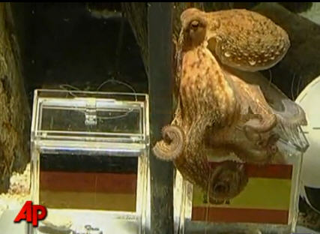
And talking of China, there was a report the other day that Cantonese is a dying dialect in Guangdong! Most of its 70 million population, except the elderly, are able to also speak Putongwa (Mandarin) and there is a suggestion that all TV stations switch to this when the Asian Games are held in Guangzhou soon.
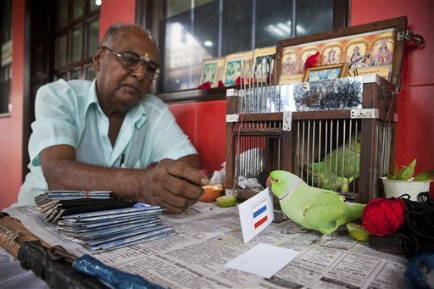
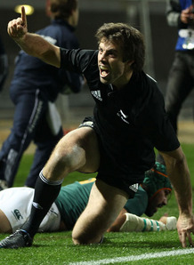
Well, the World Cup is in its final weekend, but I guess it is receiving little coverage in the US. I am not really following it, but am, like many others, intrigued with Paul the 'psychic' octopus. Have you heard of him? He is an octopus in an aquarium in Germany, and has correctly predicted the winner of every game involving Germany. He is given two identical glass containers of food with flags of each team. The container from which he takes the food is deemed to be his prediction as to which team will win (including Spain beating Germany in the semi-final, as in the picture). His only prediction for games not involving Germany is the final for which he predicts Spain to beat the Netherlands. We shall see. However, Paul has competition from a 'psychic' parakeet in Singapore which has correctly predicted the winners of the quarter-finals and one semi-final but predicts the Netherlands to win the final.
The Tri-Nations tournament began yesterday with the ABs playing the Springboks in Auckland. I decided to watch it on TV. The ABs dominated the game and won by 32-12. As they scored 4 tries, they also earned a bonus point (in addition to the 3 points for the win). They meet again next Saturday in Wellington.
That seems to be it for now.
Cheers

